Government reacts to Ghana International School (GIS) land takeover attempt.
“The government has no interest in the land in question”
The Government is reacting to news circulating in the country that it is involved in a land tussle with the Ghana International School (GIS).
A statement signed by the Director of Communications at the Office of the President, Eugene Arhin, in denial of involvement said the government has no interest in the land in question.
“No officer, agent or assign has been directed to secure and/or interfere on any matter pertaining to land within Cantonments”, the Government statement dated Sept 5, 2024, said.
According to the government, Chief Supt Ibrahim Opoku of the VVIP Unit of the COP did his professional duty by handing over alleged encroachers and suspects to the Cantonments Police Station when he chanced upon an altercation at the Cantonments barriers on his way from work.
In the statement, the government urged the general public to ignore any contradictory information, labelling it as false.
Below is the full statement of the Government:

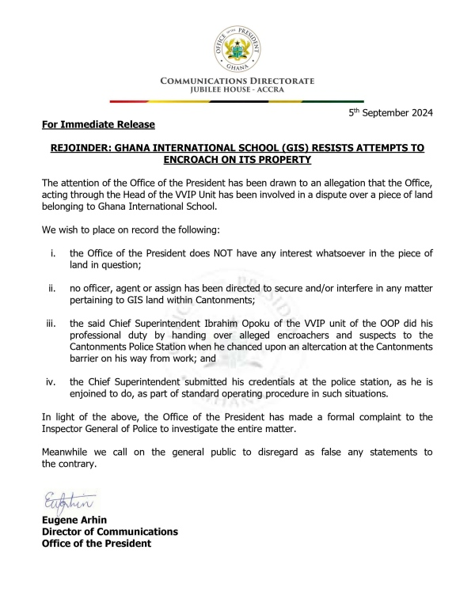

Story: Oppong Baah

